# Week-2 Evidence Bundle

Prepared by: Sahil Danecha

Organization: CyArt

Date: 21 Nov, 2025

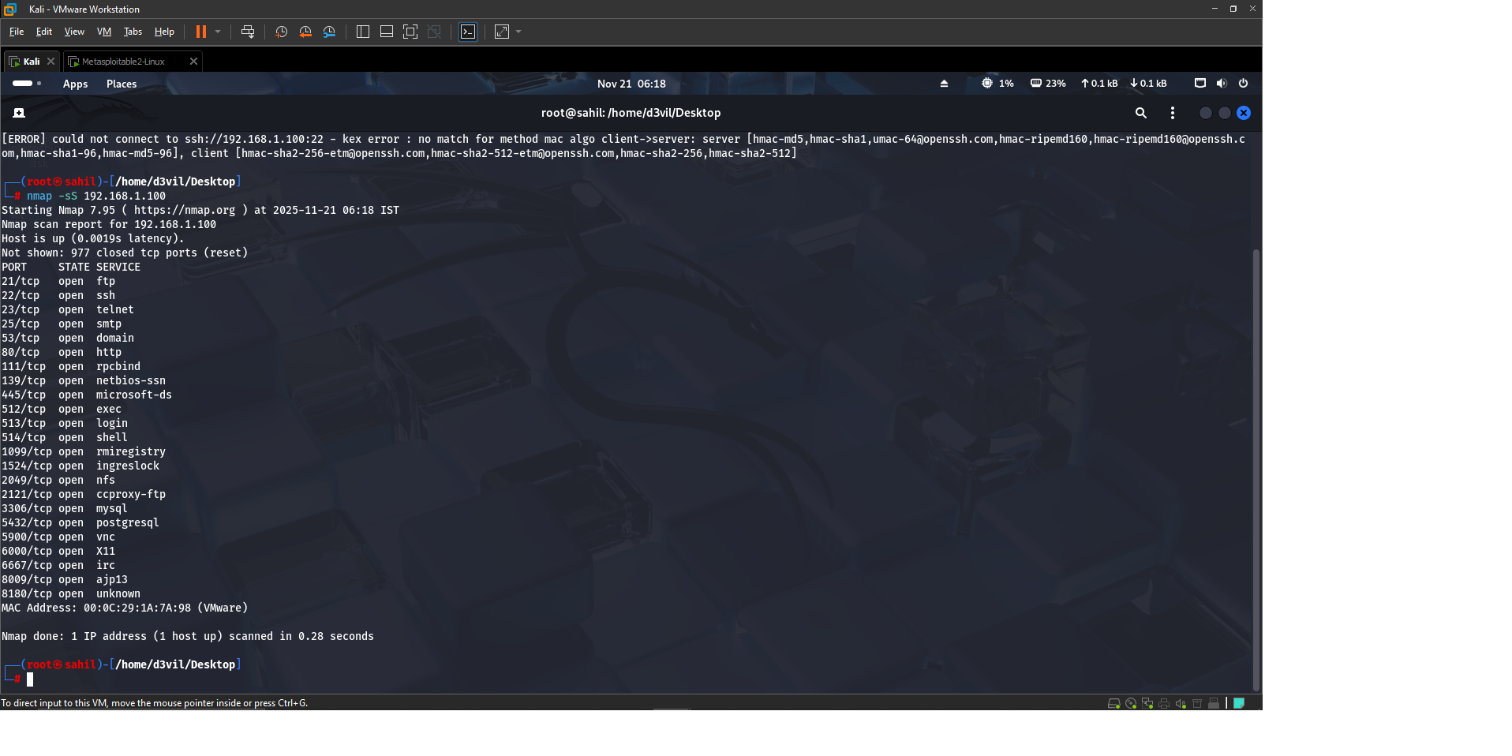

Figure: Port Scan Evidence

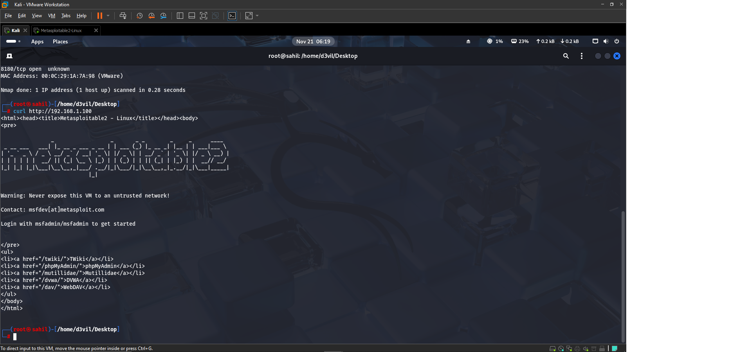

Figure: HTTP Request Evidence

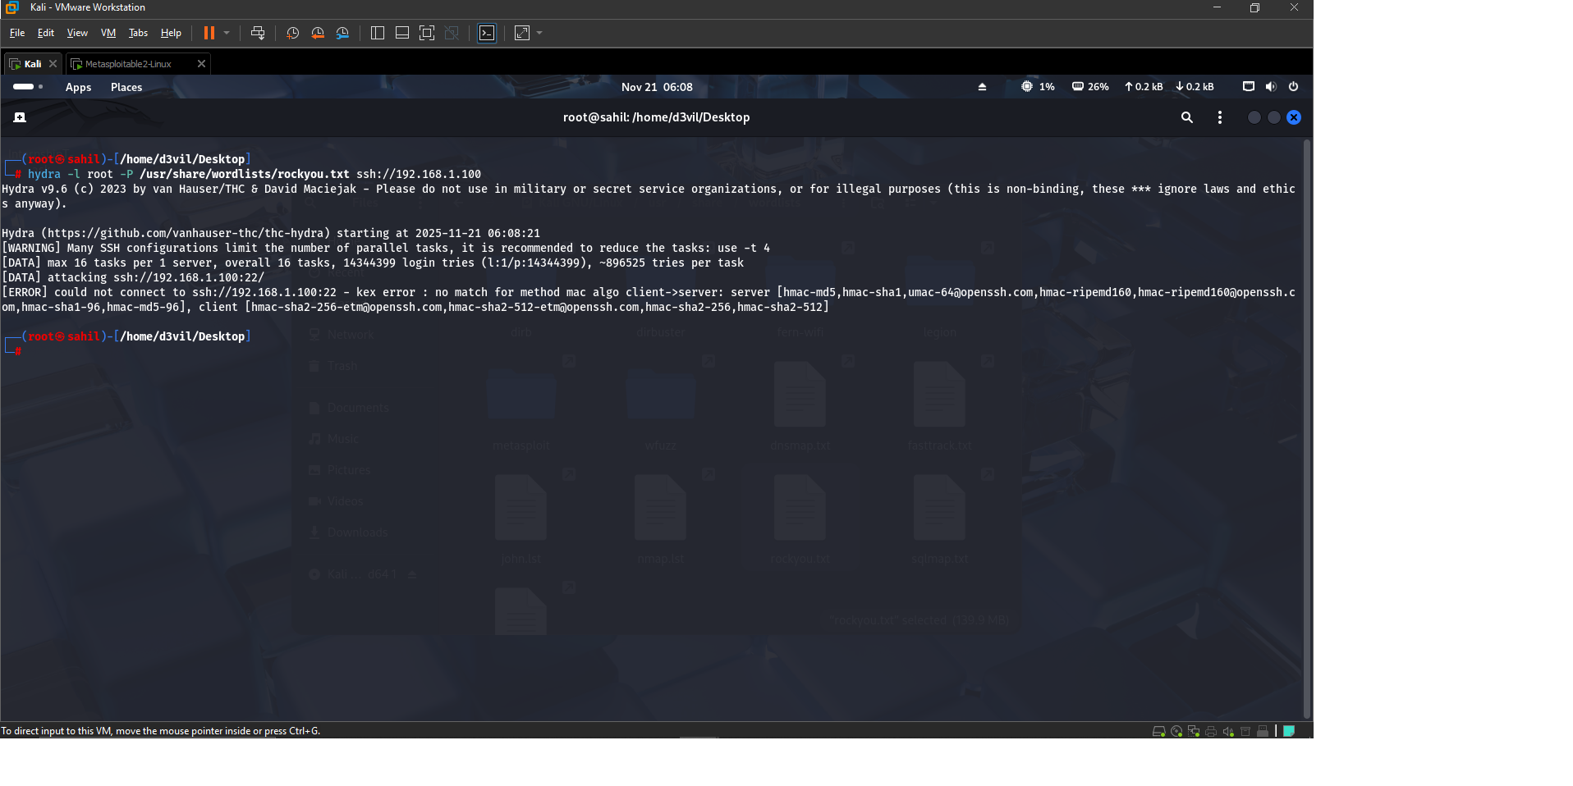

Figure: Hydra Brute Force Evidence

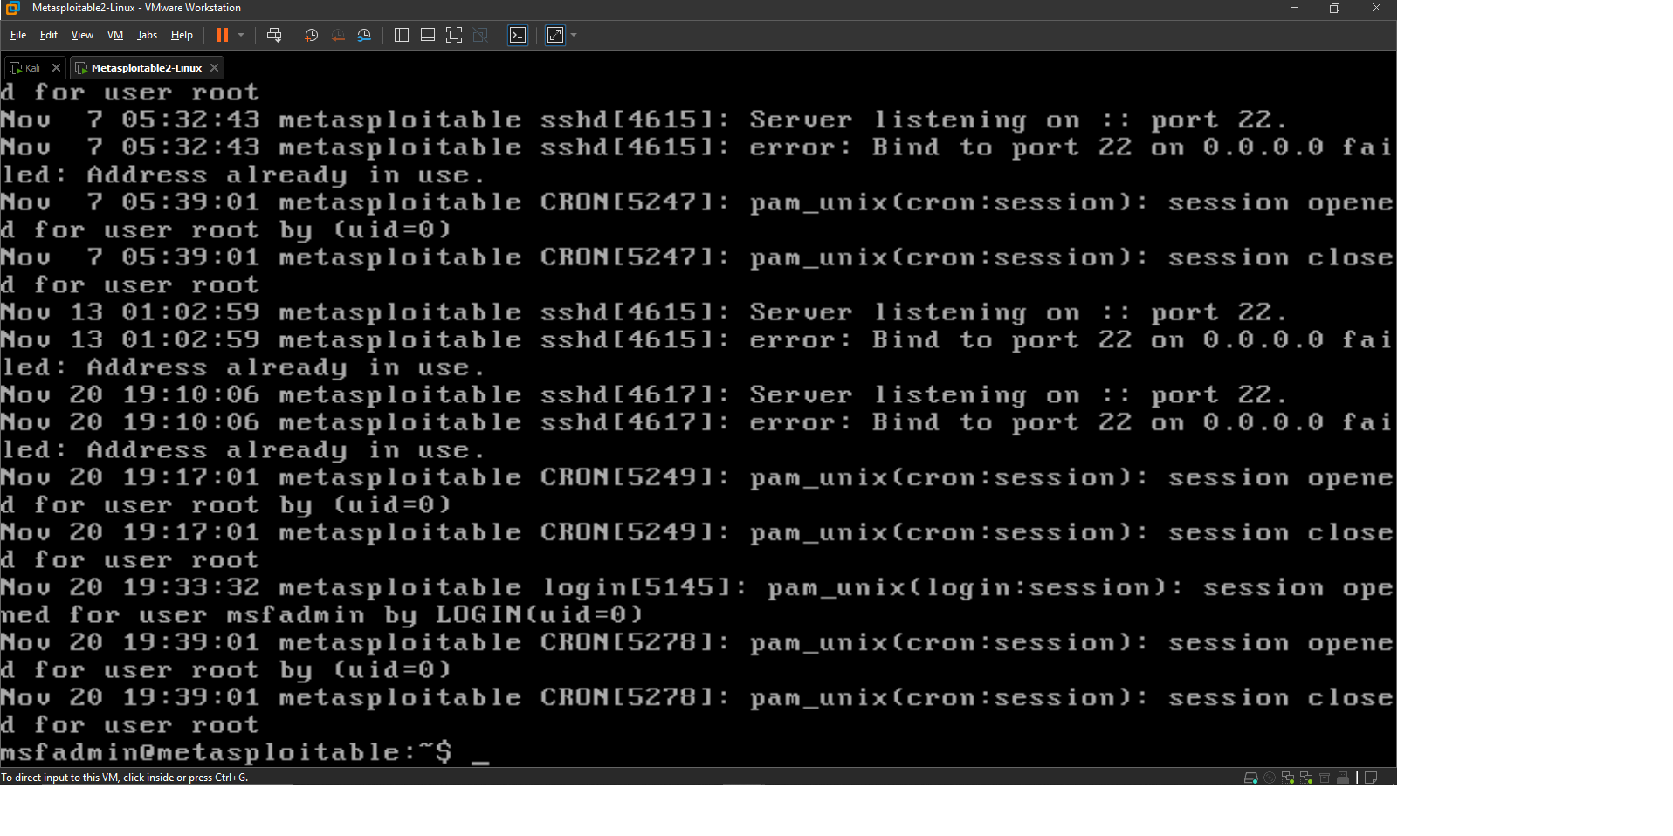

Figure: SSH auth.log Evidence

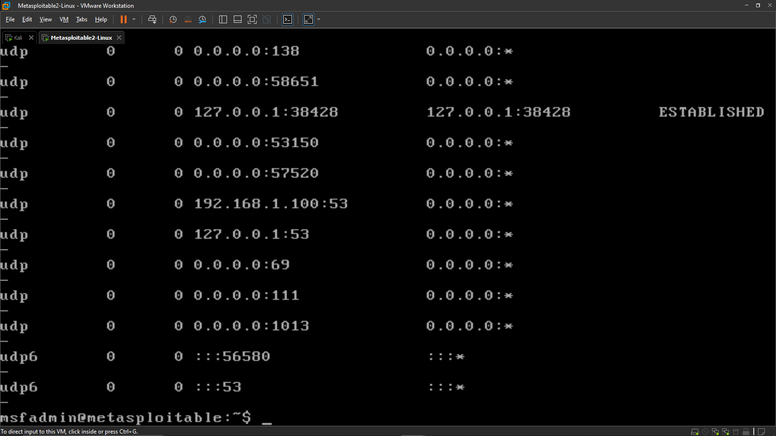

Figure: Metasploitable Netstat Output

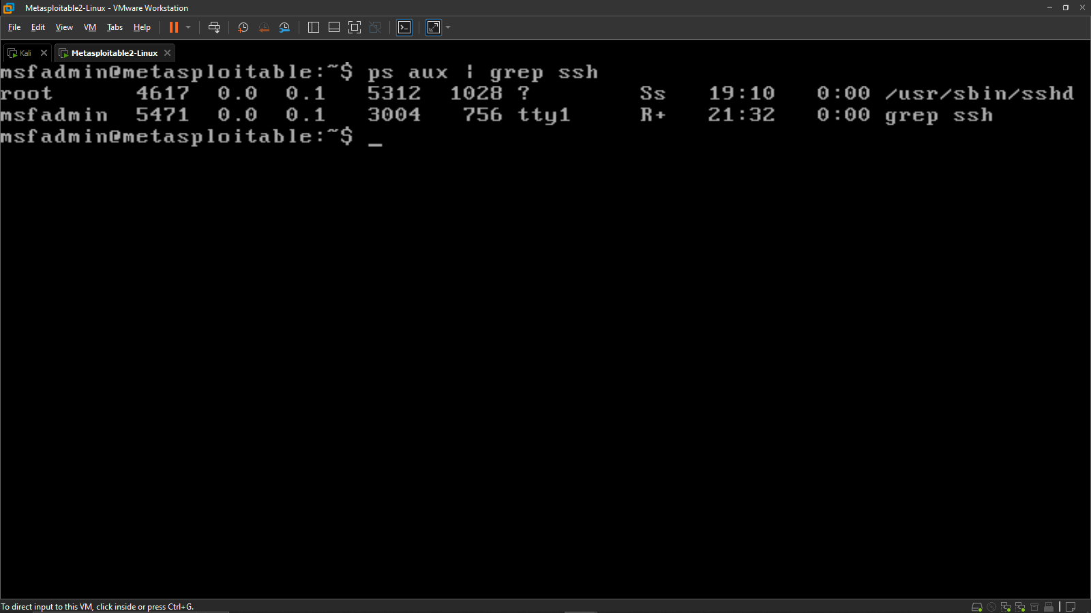

Figure: SSH Process Evidence

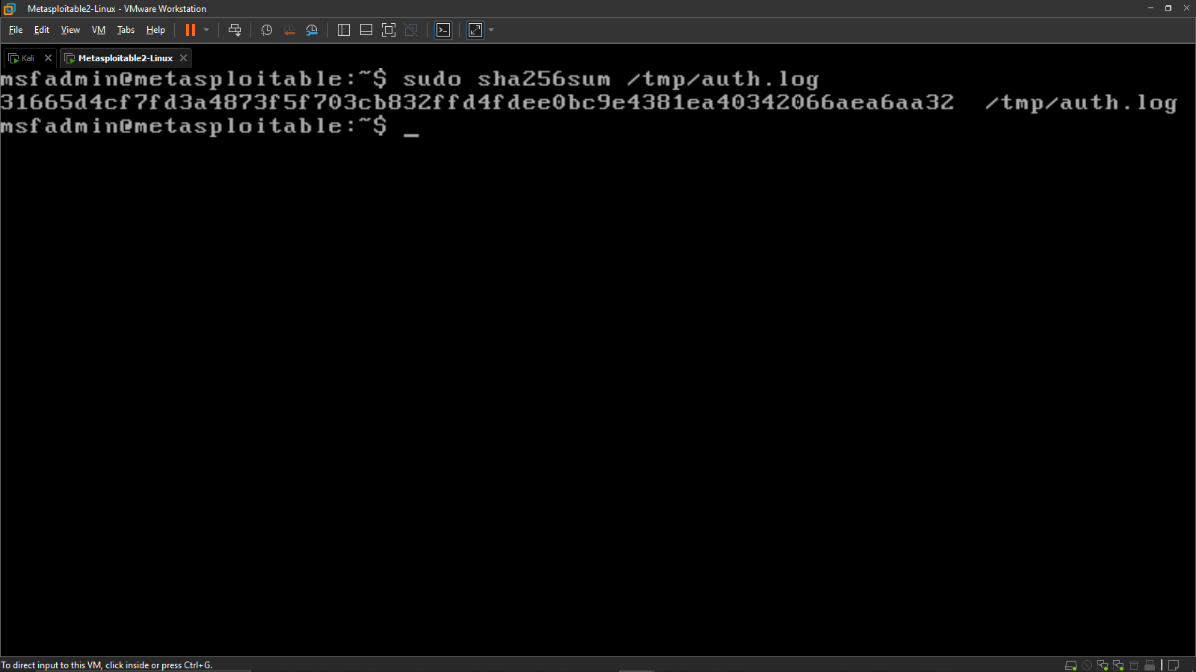

Figure: SHA256 Hash Evidence

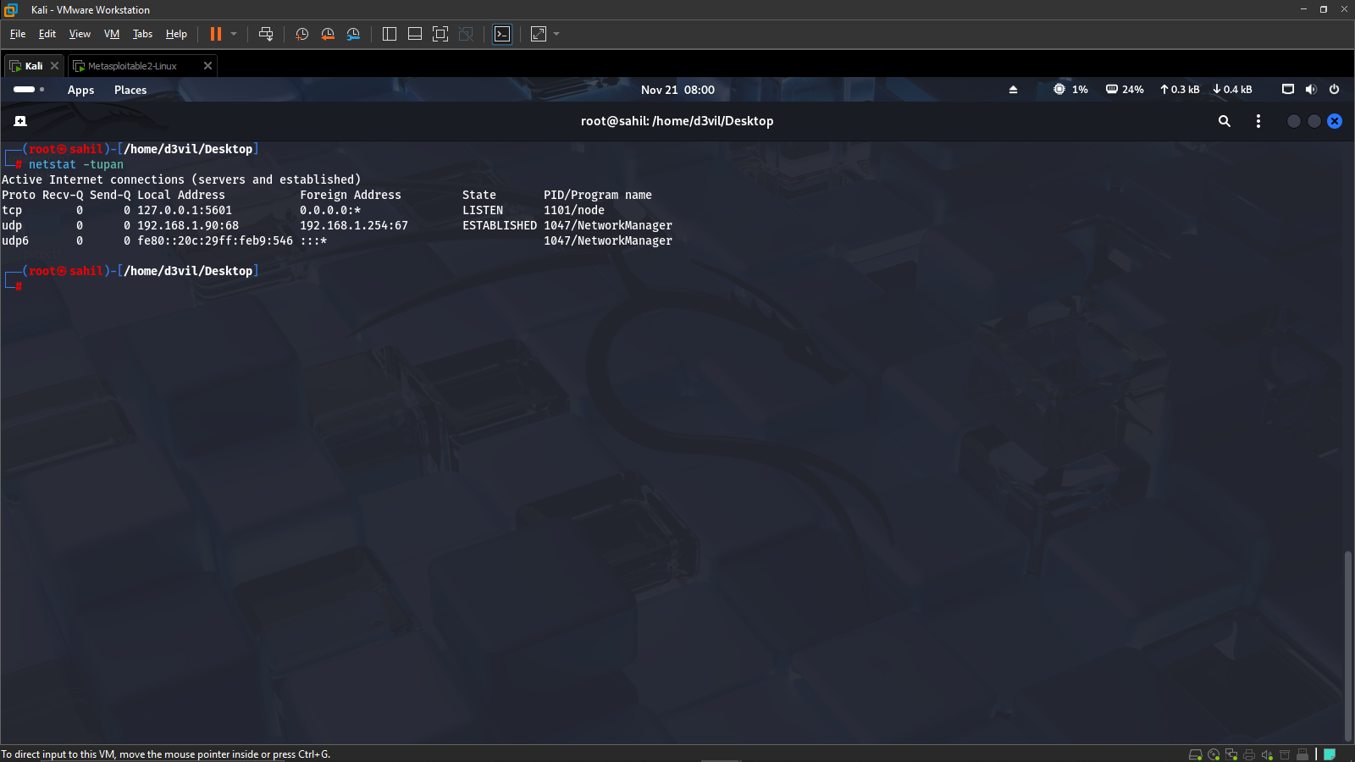

Figure: Kali Netstat Output

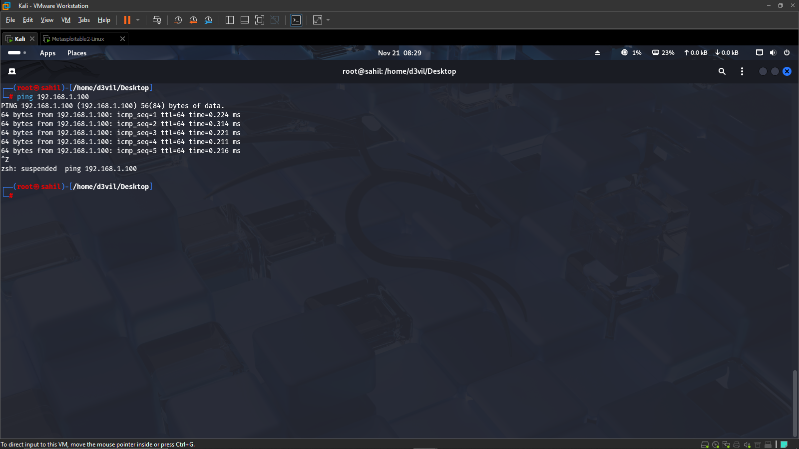

Figure: Ping Connectivity Check

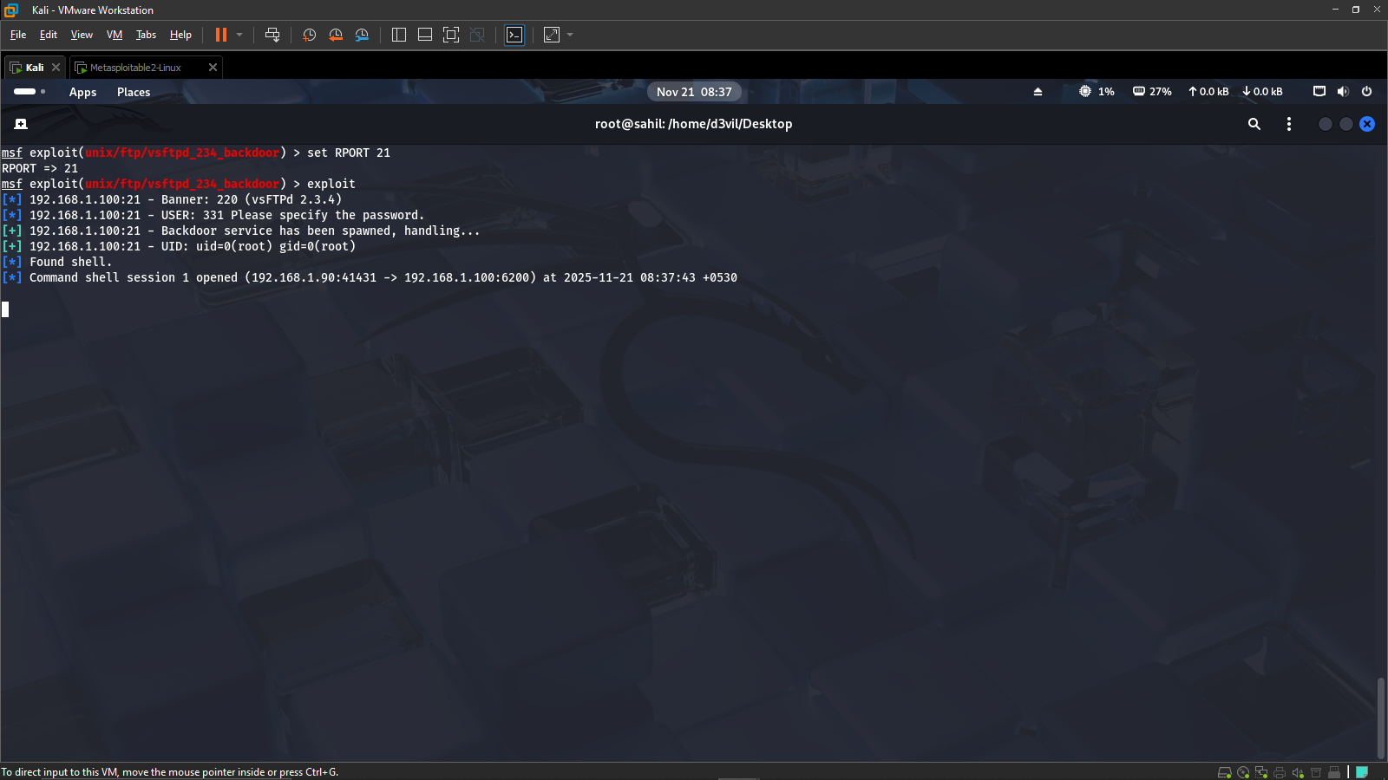

Figure: VSFTPD Exploit Success

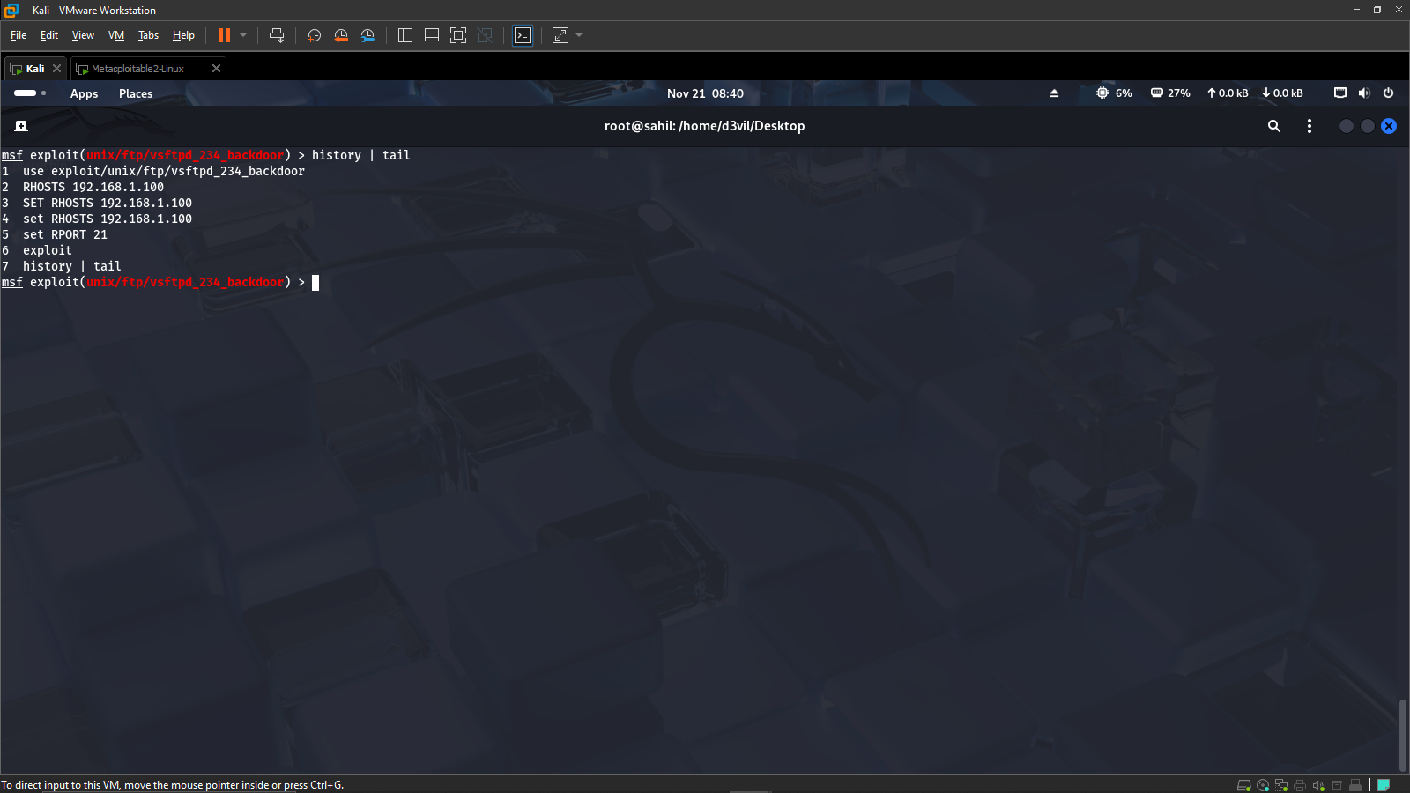

Figure: Attacker Command History

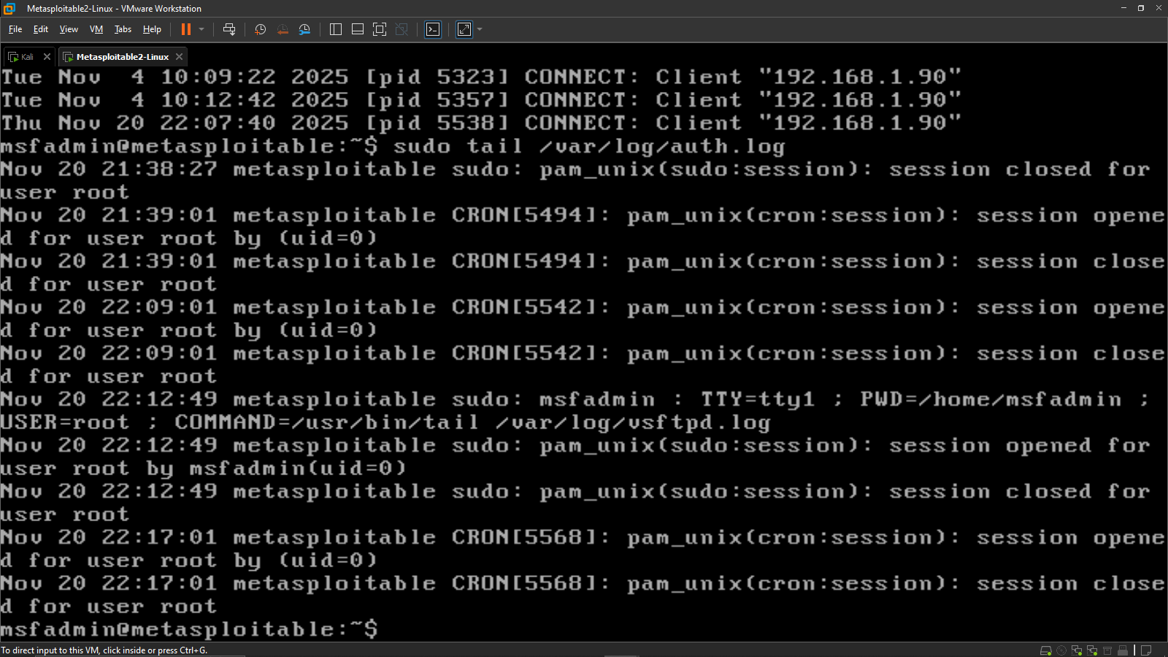

Figure: FTP Log Evidence